**Day 4 tasks - Output**

1. **Program in anonymous function & IIFE:**
2. **Print odd numbers in an array**



1. **Convert all the strings to title caps in a string array**



**C) Sum of all numbers in an array**

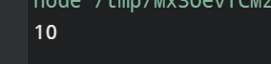

**D) Return all the prime numbers in an array**